EXPERIMENT-1

AIM:

To find the equivalent resistance using series parallel reduction.

PROCEDURE:

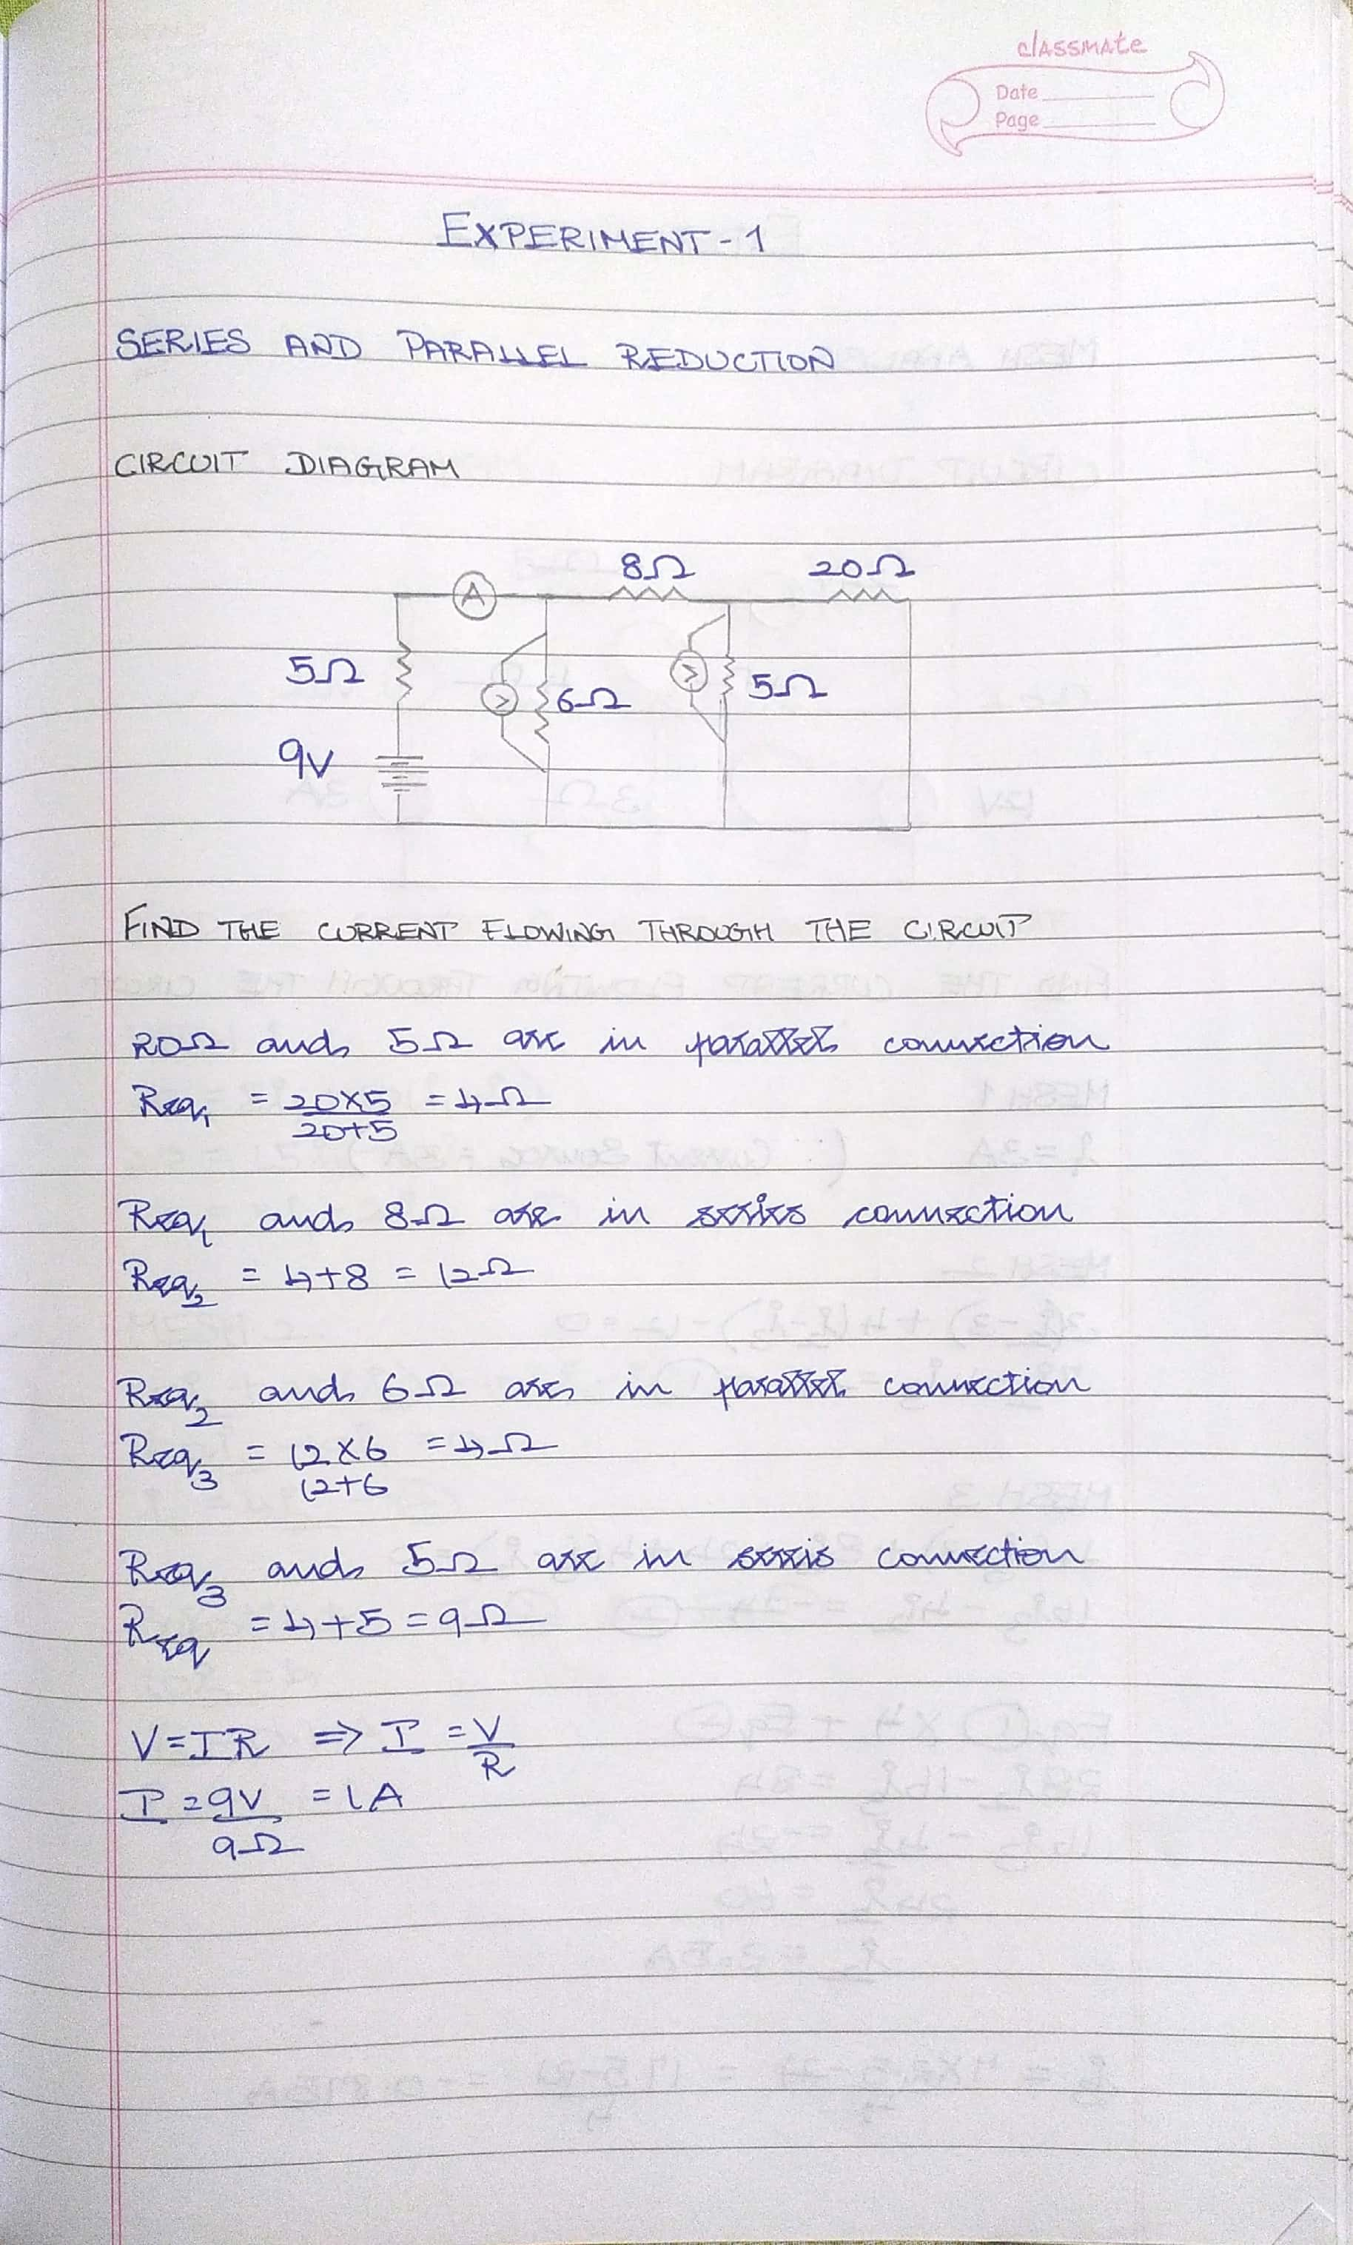

MULTISIM:

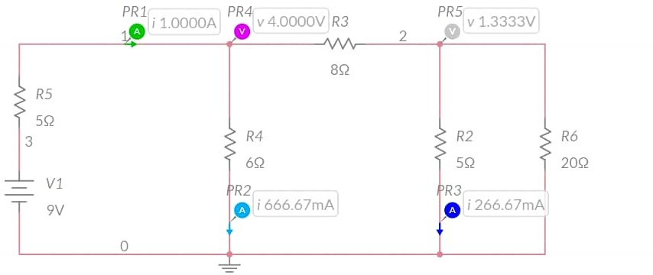

CONCLUSION:

The current value calculated theoretically and through MULTISIM are the same. Therefore, the equivalent resistance calculated theoretically is correct.

Effective current value=1A & effective resistance value=9ohms

NAME: G R NITIN

ROLL NO: CB.EN.U4CYS21017